
ASTRA 2008
Pulcini 1999

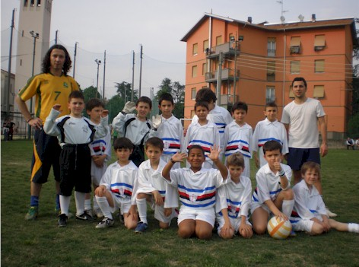
Bortone Luca Calcagno Riccardo
Calzetti Marco Ziveri Tommaso
Chiavarini Matteo Della Stefano
Fantini Tommaso Gotelli Alessandro
Montanari Sidney Pinto Lorenzo
Piroli Davide Popa Gheorghe
Pugnana Alessandro Raboni Edoardo
Salvadori Riccardo Sansone Emanuele
Camisani Calzolari Tommaso

Vitali Adriano Cocozza Fausto
Bortone Luciano

M A R Z O
L | M | M | G | V | S | D
 |  |  |  |  | 1 | 2
3 | 4 | 5 | 6 | 7 | 8 | 9
10 | 11 | 12 | 13 | 14 | 15 | 16
17 | 18 | 19 | 20 | 21 | 22 | 23
24 | 25 | 26 | 27 | 28 | 29 | 30
31

G I U G N O
L | M | M | G | V | S | D
 |  |  |  |  |  | 1
2 | 3 | 4 | 5 | 6 | 7 | 8
9 | 10 | 11 | 12 | 13 | 14 | 15
16 | 17 | 18 | 19 | 20 | 21 | 22
23 | 24 | 25 | 26 | 27 | 28 | 29
30

S E T T E M B R E
L | M | M | G | V | S | D
1 | 2 | 3 | 4 | 5 | 6 | 7
8 | 9 | 10 | 11 | 12 | 13 | 14
15 | 16 | 17 | 18 | 19 | 20 | 21
22 | 23 | 24 | 25 | 26 | 27 | 28
29 | 30

G E N N A I O
L | M | M | G | V | S | D
 |  |  |  | 1 | 2 | 3
7 | 8 | 9 | 10 | 11 | 12 | 13
14 | 15 | 16 | 17 | 18 | 19 | 20
21 | 22 | 23 | 24 | 25 | 26 | 27
28 | 29 | 30 | 31

F E B B R A I O
L | M | M | G | V | S | D
 |  |  |  | 1 | 2 | 3
4 | 5 | 6 | 7 | 8 | 9 | 10
11 | 12 | 13 | 14 | 15 | 16 | 17
18 | 19 | 20 | 21 | 22 | 23 | 24
25 | 26 | 27 | 28 | 29

A P R I L E
L | M | M | G | V | S | D
 | 1 | 2 | 3 | 4 | 5 | 6
7 | 8 | 9 | 10 | 11 | 12 | 13
14 | 15 | 16 | 17 | 18 | 19 | 20
21 | 22 | 23 | 24 | 25 | 26 | 27
28 | 29 | 30

D I C E M B R E
L | M | M | G | V | S | D
1 | 2 | 3 | 4 | 5 | 6 | 7
8 | 9 | 10 | 11 | 12 | 13 | 14
15 | 16 | 17 | 18 | 19 | 20 | 21
22 | 23 | 24 | 25 | 26 | 27 | 28
29 | 30 | 31

M A G G I O
L | M | M | G | V | S | D
 |  |  | 1 | 2 | 3 | 4
5 | 6 | 7 | 8 | 9 | 10 | 11
12 | 13 | 14 | 15 | 16 | 17 | 18
19 | 20 | 21 | 22 | 23 | 24 | 25
26 | 27 | 28 | 29 | 30 | 31

L U G L I O
L | M | M | G | V | S | D
 | 1 | 2 | 3 | 4 | 5 | 6
7 | 8 | 9 | 10 | 11 | 12 | 13
14 | 15 | 16 | 17 | 18 | 19 | 20
21 | 22 | 23 | 24 | 25 | 26 | 27
28 | 29 | 30 | 31

A G O S T O
L | M | M | G | V | S | D
 |  |  |  | 1 | 2 | 3
4 | 5 | 6 | 7 | 8 | 9 | 10
11 | 12 | 13 | 14 | 15 | 16 | 17
18 | 19 | 20 | 21 | 22 | 23 | 24
25 | 26 | 27 | 28 | 29 | 30 | 31

O T T O B R E
L | M | M | G | V | S | D
 |  | 1 | 2 | 3 | 4 | 5
6 | 7 | 8 | 9 | 10 | 11 | 13
12 | 13 | 14 | 15 | 16 | 17 | 18
19 | 20 | 21 | 22 | 23 | 24 | 25
26 | 29 | 28 | 30 | 31

N O V E M B R E
L | M | M | G | V | S | D
 |  |  |  |  | 1 | 2
3 | 4 | 5 | 6 | 7 | 8 | 9
10 | 11 | 12 | 13 | 14 | 15 | 16
17 | 18 | 19 | 20 | 21 | 22 | 23
24 | 25 | 26 | 27 | 28 | 29 | 30

