
ASTRA 2008
PULCINI 1998

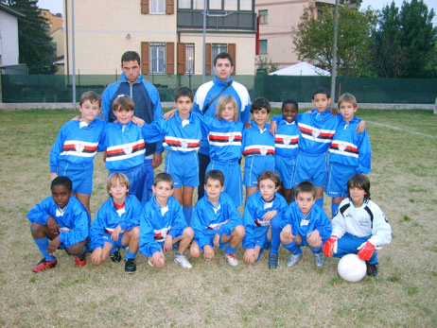
Benassi Michele Bertini Leonardo
Bocchia Stefano Bottarelli Lorenzo
Bouraoui Ayoub Cantatori Federico
Dedia Alessandro Fontana Fabio
Idda Alessandro Laknitri Anas
Marcotti Mattia Mbengue Abdu
Mbengue Ousseinou Mordacci Nicola
Picello Andrea Prekaj Arnold
Smalay Leon

Bellini Francesco Fior Emanuele
Salsi Pietro Rozzi Mauro

M A R Z O
L | M | M | G | V | S | D
 |  |  |  |  | 1 | 2
3 | 4 | 5 | 6 | 7 | 8 | 9
10 | 11 | 12 | 13 | 14 | 15 | 16
17 | 18 | 19 | 20 | 21 | 22 | 23
24 | 25 | 26 | 27 | 28 | 29 | 30
31

G I U G N O
L | M | M | G | V | S | D
 |  |  |  |  |  | 1
2 | 3 | 4 | 5 | 6 | 7 | 8
9 | 10 | 11 | 12 | 13 | 14 | 15
16 | 17 | 18 | 19 | 20 | 21 | 22
23 | 24 | 25 | 26 | 27 | 28 | 29
30

S E T T E M B R E
L | M | M | G | V | S | D
1 | 2 | 3 | 4 | 5 | 6 | 7
8 | 9 | 10 | 11 | 12 | 13 | 14
15 | 16 | 17 | 18 | 19 | 20 | 21
22 | 23 | 24 | 25 | 26 | 27 | 28
29 | 30

G E N N A I O
L | M | M | G | V | S | D
 |  |  |  | 1 | 2 | 3
7 | 8 | 9 | 10 | 11 | 12 | 13
14 | 15 | 16 | 17 | 18 | 19 | 20
21 | 22 | 23 | 24 | 25 | 26 | 27
28 | 29 | 30 | 31

F E B B R A I O
L | M | M | G | V | S | D
 |  |  |  | 1 | 2 | 3
4 | 5 | 6 | 7 | 8 | 9 | 10
11 | 12 | 13 | 14 | 15 | 16 | 17
18 | 19 | 20 | 21 | 22 | 23 | 24
25 | 26 | 27 | 28 | 29

A P R I L E
L | M | M | G | V | S | D
 | 1 | 2 | 3 | 4 | 5 | 6
7 | 8 | 9 | 10 | 11 | 12 | 13
14 | 15 | 16 | 17 | 18 | 19 | 20
21 | 22 | 23 | 24 | 25 | 26 | 27
28 | 29 | 30

D I C E M B R E
L | M | M | G | V | S | D
1 | 2 | 3 | 4 | 5 | 6 | 7
8 | 9 | 10 | 11 | 12 | 13 | 14
15 | 16 | 17 | 18 | 19 | 20 | 21
22 | 23 | 24 | 25 | 26 | 27 | 28
29 | 30 | 31

M A G G I O
L | M | M | G | V | S | D
 |  |  | 1 | 2 | 3 | 4
5 | 6 | 7 | 8 | 9 | 10 | 11
12 | 13 | 14 | 15 | 16 | 17 | 18
19 | 20 | 21 | 22 | 23 | 24 | 25
26 | 27 | 28 | 29 | 30 | 31

L U G L I O
L | M | M | G | V | S | D
 | 1 | 2 | 3 | 4 | 5 | 6
7 | 8 | 9 | 10 | 11 | 12 | 13
14 | 15 | 16 | 17 | 18 | 19 | 20
21 | 22 | 23 | 24 | 25 | 26 | 27
28 | 29 | 30 | 31

A G O S T O
L | M | M | G | V | S | D
 |  |  |  | 1 | 2 | 3
4 | 5 | 6 | 7 | 8 | 9 | 10
11 | 12 | 13 | 14 | 15 | 16 | 17
18 | 19 | 20 | 21 | 22 | 23 | 24
25 | 26 | 27 | 28 | 29 | 30 | 31

O T T O B R E
L | M | M | G | V | S | D
 |  | 1 | 2 | 3 | 4 | 5
6 | 7 | 8 | 9 | 10 | 11 | 13
12 | 13 | 14 | 15 | 16 | 17 | 18
19 | 20 | 21 | 22 | 23 | 24 | 25
26 | 29 | 28 | 30 | 31

N O V E M B R E
L | M | M | G | V | S | D
 |  |  |  |  | 1 | 2
3 | 4 | 5 | 6 | 7 | 8 | 9
10 | 11 | 12 | 13 | 14 | 15 | 16
17 | 18 | 19 | 20 | 21 | 22 | 23
24 | 25 | 26 | 27 | 28 | 29 | 30

