
ASTRA 2008
Pulcini 1997

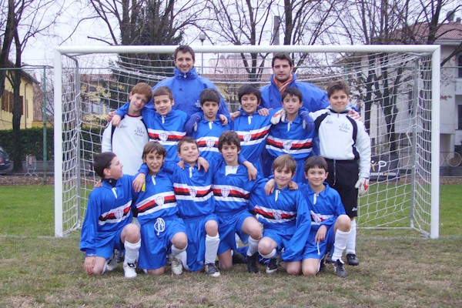
Bernini Filippo Bocchi Pierluigi
Cavalli Federico Cavazzini Michele
Cavozza Matteo Cocconi Davide
Della Alessandro Farruggia Simone
Ghillani Francesco Groppi Davide
Martinelli Federico Mbengue Mor
Michelotti Leonardo Nani Alessandro
Orlandi Simone Petroccione Rocco
Porta Mattia Robuschi Pietro
Secchi Federico Tommasini Marcello
Wert Alexander Zambelli Filippo

Stori Anapì Lopresti Francesco
Baistrocchi Pierluigi

M A R Z O
L | M | M | G | V | S | D
 |  |  |  |  | 1 | 2
3 | 4 | 5 | 6 | 7 | 8 | 9
10 | 11 | 12 | 13 | 14 | 15 | 16
17 | 18 | 19 | 20 | 21 | 22 | 23
24 | 25 | 26 | 27 | 28 | 29 | 30
31

G I U G N O
L | M | M | G | V | S | D
 |  |  |  |  |  | 1
2 | 3 | 4 | 5 | 6 | 7 | 8
9 | 10 | 11 | 12 | 13 | 14 | 15
16 | 17 | 18 | 19 | 20 | 21 | 22
23 | 24 | 25 | 26 | 27 | 28 | 29
30

S E T T E M B R E
L | M | M | G | V | S | D
1 | 2 | 3 | 4 | 5 | 6 | 7
8 | 9 | 10 | 11 | 12 | 13 | 14
15 | 16 | 17 | 18 | 19 | 20 | 21
22 | 23 | 24 | 25 | 26 | 27 | 28
29 | 30

G E N N A I O
L | M | M | G | V | S | D
 |  |  |  | 1 | 2 | 3
7 | 8 | 9 | 10 | 11 | 12 | 13
14 | 15 | 16 | 17 | 18 | 19 | 20
21 | 22 | 23 | 24 | 25 | 26 | 27
28 | 29 | 30 | 31

F E B B R A I O
L | M | M | G | V | S | D
 |  |  |  | 1 | 2 | 3
4 | 5 | 6 | 7 | 8 | 9 | 10
11 | 12 | 13 | 14 | 15 | 16 | 17
18 | 19 | 20 | 21 | 22 | 23 | 24
25 | 26 | 27 | 28 | 29

A P R I L E
L | M | M | G | V | S | D
 | 1 | 2 | 3 | 4 | 5 | 6
7 | 8 | 9 | 10 | 11 | 12 | 13
14 | 15 | 16 | 17 | 18 | 19 | 20
21 | 22 | 23 | 24 | 25 | 26 | 27
28 | 29 | 30

D I C E M B R E
L | M | M | G | V | S | D
1 | 2 | 3 | 4 | 5 | 6 | 7
8 | 9 | 10 | 11 | 12 | 13 | 14
15 | 16 | 17 | 18 | 19 | 20 | 21
22 | 23 | 24 | 25 | 26 | 27 | 28
29 | 30 | 31

M A G G I O
L | M | M | G | V | S | D
 |  |  | 1 | 2 | 3 | 4
5 | 6 | 7 | 8 | 9 | 10 | 11
12 | 13 | 14 | 15 | 16 | 17 | 18
19 | 20 | 21 | 22 | 23 | 24 | 25
26 | 27 | 28 | 29 | 30 | 31

L U G L I O
L | M | M | G | V | S | D
 | 1 | 2 | 3 | 4 | 5 | 6
7 | 8 | 9 | 10 | 11 | 12 | 13
14 | 15 | 16 | 17 | 18 | 19 | 20
21 | 22 | 23 | 24 | 25 | 26 | 27
28 | 29 | 30 | 31

A G O S T O
L | M | M | G | V | S | D
 |  |  |  | 1 | 2 | 3
4 | 5 | 6 | 7 | 8 | 9 | 10
11 | 12 | 13 | 14 | 15 | 16 | 17
18 | 19 | 20 | 21 | 22 | 23 | 24
25 | 26 | 27 | 28 | 29 | 30 | 31

O T T O B R E
L | M | M | G | V | S | D
 |  | 1 | 2 | 3 | 4 | 5
6 | 7 | 8 | 9 | 10 | 11 | 13
12 | 13 | 14 | 15 | 16 | 17 | 18
19 | 20 | 21 | 22 | 23 | 24 | 25
26 | 29 | 28 | 30 | 31

N O V E M B R E
L | M | M | G | V | S | D
 |  |  |  |  | 1 | 2
3 | 4 | 5 | 6 | 7 | 8 | 9
10 | 11 | 12 | 13 | 14 | 15 | 16
17 | 18 | 19 | 20 | 21 | 22 | 23
24 | 25 | 26 | 27 | 28 | 29 | 30

