
ASTRA 2008
Esordienti 1994

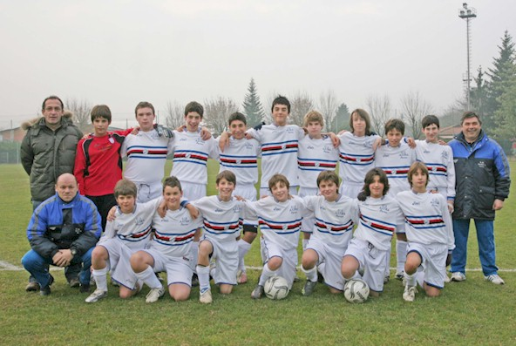
Biasin Francesco Bocchia Paolo
Bortone Nicolo' Camisani Calzolari Iacopo
Capretti Andrea Cariello Pietro
Carrara Marco Choiwa Alessandro
Dasso Mattia Febbo Federico
Lohja Stiven Pedrazzi Jacopo
Penzo Marco Pettenati Francesco
Romeo Davide Rotelli Fabio
Ruisi Lorenzo Villa Luca

Burani Antonio Foranzi Roberto
Biasin Guido

M A R Z O
L | M | M | G | V | S | D
 |  |  |  |  | 1 | 2
3 | 4 | 5 | 6 | 7 | 8 | 9
10 | 11 | 12 | 13 | 14 | 15 | 16
17 | 18 | 19 | 20 | 21 | 22 | 23
24 | 25 | 26 | 27 | 28 | 29 | 30
31

G I U G N O
L | M | M | G | V | S | D
 |  |  |  |  |  | 1
2 | 3 | 4 | 5 | 6 | 7 | 8
9 | 10 | 11 | 12 | 13 | 14 | 15
16 | 17 | 18 | 19 | 20 | 21 | 22
23 | 24 | 25 | 26 | 27 | 28 | 29
30

S E T T E M B R E
L | M | M | G | V | S | D
1 | 2 | 3 | 4 | 5 | 6 | 7
8 | 9 | 10 | 11 | 12 | 13 | 14
15 | 16 | 17 | 18 | 19 | 20 | 21
22 | 23 | 24 | 25 | 26 | 27 | 28
29 | 30

G E N N A I O
L | M | M | G | V | S | D
 |  |  |  | 1 | 2 | 3
7 | 8 | 9 | 10 | 11 | 12 | 13
14 | 15 | 16 | 17 | 18 | 19 | 20
21 | 22 | 23 | 24 | 25 | 26 | 27
28 | 29 | 30 | 31

F E B B R A I O
L | M | M | G | V | S | D
 |  |  |  | 1 | 2 | 3
4 | 5 | 6 | 7 | 8 | 9 | 10
11 | 12 | 13 | 14 | 15 | 16 | 17
18 | 19 | 20 | 21 | 22 | 23 | 24
25 | 26 | 27 | 28 | 29

A P R I L E
L | M | M | G | V | S | D
 | 1 | 2 | 3 | 4 | 5 | 6
7 | 8 | 9 | 10 | 11 | 12 | 13
14 | 15 | 16 | 17 | 18 | 19 | 20
21 | 22 | 23 | 24 | 25 | 26 | 27
28 | 29 | 30

D I C E M B R E
L | M | M | G | V | S | D
1 | 2 | 3 | 4 | 5 | 6 | 7
8 | 9 | 10 | 11 | 12 | 13 | 14
15 | 16 | 17 | 18 | 19 | 20 | 21
22 | 23 | 24 | 25 | 26 | 27 | 28
29 | 30 | 31

M A G G I O
L | M | M | G | V | S | D
 |  |  | 1 | 2 | 3 | 4
5 | 6 | 7 | 8 | 9 | 10 | 11
12 | 13 | 14 | 15 | 16 | 17 | 18
19 | 20 | 21 | 22 | 23 | 24 | 25
26 | 27 | 28 | 29 | 30 | 31

L U G L I O
L | M | M | G | V | S | D
 | 1 | 2 | 3 | 4 | 5 | 6
7 | 8 | 9 | 10 | 11 | 12 | 13
14 | 15 | 16 | 17 | 18 | 19 | 20
21 | 22 | 23 | 24 | 25 | 26 | 27
28 | 29 | 30 | 31

A G O S T O
L | M | M | G | V | S | D
 |  |  |  | 1 | 2 | 3
4 | 5 | 6 | 7 | 8 | 9 | 10
11 | 12 | 13 | 14 | 15 | 16 | 17
18 | 19 | 20 | 21 | 22 | 23 | 24
25 | 26 | 27 | 28 | 29 | 30 | 31

O T T O B R E
L | M | M | G | V | S | D
 |  | 1 | 2 | 3 | 4 | 5
6 | 7 | 8 | 9 | 10 | 11 | 13
12 | 13 | 14 | 15 | 16 | 17 | 18
19 | 20 | 21 | 22 | 23 | 24 | 25
26 | 29 | 28 | 30 | 31

N O V E M B R E
L | M | M | G | V | S | D
 |  |  |  |  | 1 | 2
3 | 4 | 5 | 6 | 7 | 8 | 9
10 | 11 | 12 | 13 | 14 | 15 | 16
17 | 18 | 19 | 20 | 21 | 22 | 23
24 | 25 | 26 | 27 | 28 | 29 | 30

